**Design Methodology:**

**Block Diagram:**

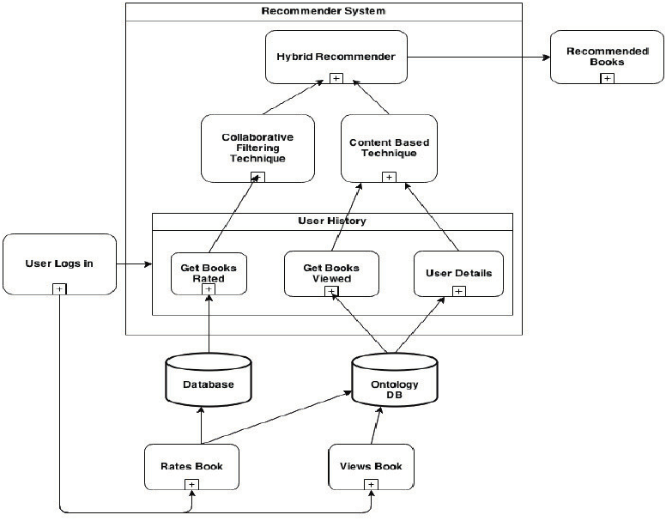

Data Flow Diagram:

Level 0:

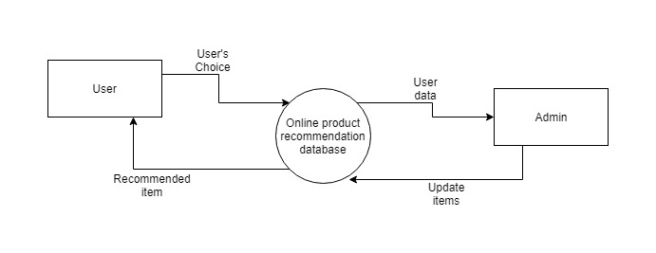

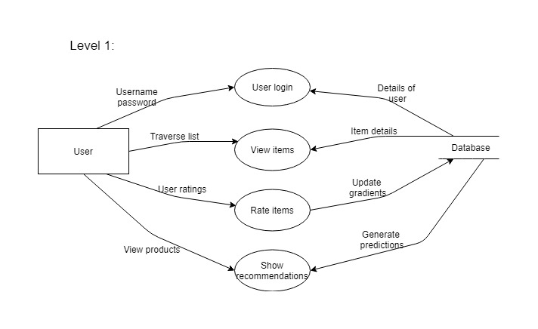

Class Diagram:

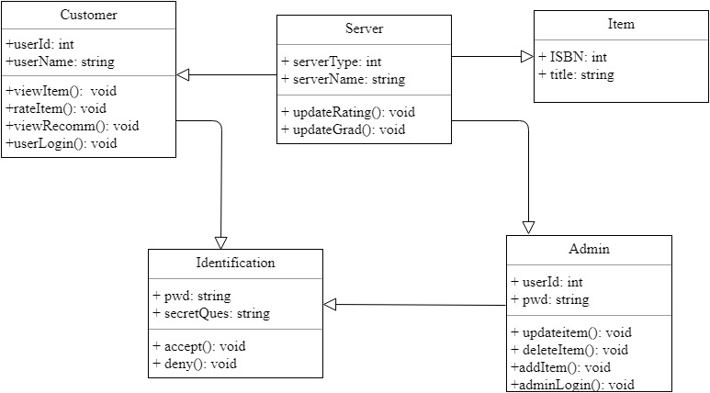

Use Case Diagram:

